LIPIDS

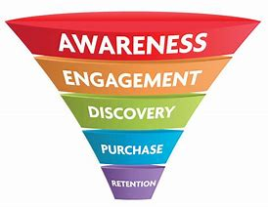

Roger Martin (Dean of the Rotman School of Management at the University of Toronto. he continues to serve as a senior advisor to CEOs of some of the world's leading companies. This article is based on concepts in his latest book. DESIGN THINKING
Successful businesses and entrepreneurs, Martin suggests, use the knowledge funnel when they work in an area with a lot of unknowns (mysteries), develop strategies for understanding and solving those unknowns (heuristics), and, eventually, develop formulaic responses (algorithms/code) to those challenges, thereby increasing productivity and effectiveness.

The Learning Funnel
Martin's knowledge funnel inspired us to think with "new eyes" about a learning funnel that can be similarly applied to learners and learning. After all, learning begins when learners encounter something they wish to learn.
Learners, including teachers, who embrace the entire learning funnel will, inevitably, move toward creating algorithms to manage what they are learning so that they have more time and energy to investigate more mysteries and thereby move again and again through the funnel.

DIGESTION AND ABSORPTION

As you have learned, the process of mechanical digestion is relatively simple. It involves the physical breakdown of food but does not alter its chemical makeup. Chemical digestion, on the other hand, is a complex process that reduces food into its chemical building blocks, which are then absorbed to nourish the cells of the body (Figure). In this class, you will look more closely at the processes of chemical digestion and absorption.

Lipid Digestion

A healthy diet limits lipid intake to 35 percent of total calorie intake. The most common dietary lipids are triglycerides, which are made up of a glycerol molecule bound to three fatty acid chains. Small amounts of dietary cholesterol and phospholipids are also consumed.

The three lipases responsible for lipid digestion are lingual lipase, gastric lipase, and pancreatic lipase. However, because the pancreas is the only consequential source of lipase, virtually all lipid digestion occurs in the small intestine. Pancreatic lipase breaks down each triglyceride into two free fatty acids and a monoglyceride. The fatty acids include both short-chain (less than 10 to 12 carbons) and long-chain fatty acids.

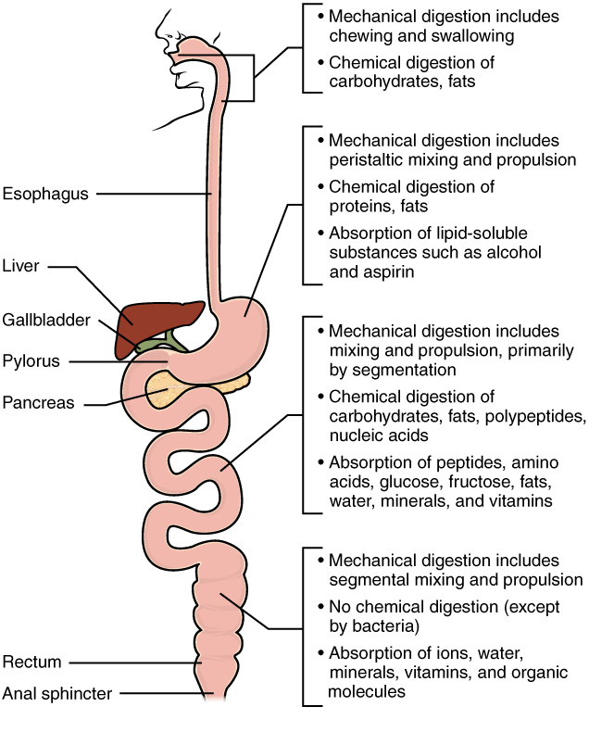

Absorption
The mechanical and digestive processes have one goal: to convert food into molecules small enough to be absorbed by the epithelial cells of the intestinal villi. The absorptive capacity of the alimentary canal is almost endless. Each day, the alimentary canal processes up to 10 liters of food, liquids, and GI secretions, yet less than one liter enters the large intestine. Almost all ingested food, 80 percent of electrolytes, and 90 percent of water are absorbed in the small intestine. Although the entire small intestine is involved in the absorption of water and lipids, most absorption of carbohydrates and proteins occurs in the jejunum. Notably, bile salts and vitamin B₁₂ are absorbed in the terminal ileum. By the time chyme passes from the ileum into the large intestine, it is essentially indigestible food residue (mainly plant fibers like cellulose), some water, and millions of bacteria (Figure).
Absorption can occur through five mechanisms: (1) active transport, (2) passive diffusion, (3) facilitated diffusion, (4) co-transport (or secondary active transport), and (5) endocytosis. As you will recall from Chapter 3, active transport refers to the movement of a substance across a cell membrane going from an area of lower concentration to an area of higher concentration (up the concentration gradient). In this type of transport, proteins within the cell membrane act as “pumps,” using cellular energy (ATP) to move the substance. Passive diffusion refers to the movement of substances from an area of higher concentration to an area of lower concentration, while facilitated diffusion refers to the movement of substances from an area of higher to an area of lower concentration using a carrier protein in the cell membrane. Co-transport uses the movement of one molecule through the membrane from higher to lower concentration to power the movement of another from lower to higher. Finally, endocytosis is a transportation process in which the cell membrane engulfs material. It requires energy, generally in the form of ATP.
Because the cell’s plasma membrane is made up of hydrophobic phospholipids, water-soluble nutrients must use transport molecules embedded in the membrane to enter cells. Moreover, substances cannot pass between the epithelial cells of the intestinal mucosa because these cells are bound together by tight junctions. Thus, substances can only enter blood capillaries by passing through the apical surfaces of epithelial cells and into the interstitial fluid. Water-soluble nutrients enter the capillary blood in the villi and travel to the liver via the hepatic portal vein.
In contrast to the water-soluble nutrients, lipid-soluble nutrients can diffuse through the plasma membrane. Once inside the cell, they are packaged for transport via the base of the cell and then enter the lacteals of the villi to be transported by lymphatic vessels to the systemic circulation via the thoracic duct. The absorption of most nutrients through the mucosa of the intestinal villi requires active transport fueled by ATP. The routes of absorption for each food category are summarized in Table.

Lipid Absorption
About 95 percent of lipids are absorbed in the small intestine. Bile salts not only speed up lipid digestion, they are also essential to the absorption of the end products of lipid digestion. Short-chain fatty acids are relatively water soluble and can enter the absorptive cells (enterocytes) directly. The small size of short-chain fatty acids enables them to be absorbed by enterocytes via simple diffusion, and then take the same path as monosaccharides and amino acids into the blood capillary of a villus.
The large and hydrophobic long-chain fatty acids and monoacylglycerides are not so easily suspended in the watery intestinal chyme. However, bile salts and lecithin resolve this issue by enclosing them in a micelle, which is a tiny sphere with polar (hydrophilic) ends facing the watery environment and hydrophobic tails turned to the interior, creating a receptive environment for the long-chain fatty acids. The core also includes cholesterol and fat-soluble vitamins. Without micelles, lipids would sit on the surface of chyme and never come in contact with the absorptive surfaces of the epithelial cells. Micelles can easily squeeze between microvilli and get very near the luminal cell surface. At this point, lipid substances exit the micelle and are absorbed via simple diffusion.
The free fatty acids and monoacylglycerides that enter the epithelial cells are reincorporated into triglycerides. The triglycerides are mixed with phospholipids and cholesterol, and surrounded with a protein coat. This new complex, called a chylomicron, is a water-soluble lipoprotein. After being processed by the Golgi apparatus, chylomicrons are released from the cell (Figure). Too big to pass through the basement membranes of blood capillaries, chylomicrons instead enter the large pores of lacteals. The lacteals come together to form the lymphatic vessels. The chylomicrons are transported in the lymphatic vessels and empty through the thoracic duct into the subclavian vein of the circulatory system. Once in the bloodstream, the enzyme lipoprotein lipase breaks down the triglycerides of the chylomicrons into free fatty acids and glycerol. These breakdown products then pass through capillary walls to be used for energy by cells or stored in adipose tissue as fat. Liver cells combine the remaining chylomicron remnants with proteins, forming lipoproteins that transport cholesterol in the blood.

lipoprotein lipase
enzyme that breaks down triglycerides in chylomicrons into fatty acids and monoglycerides

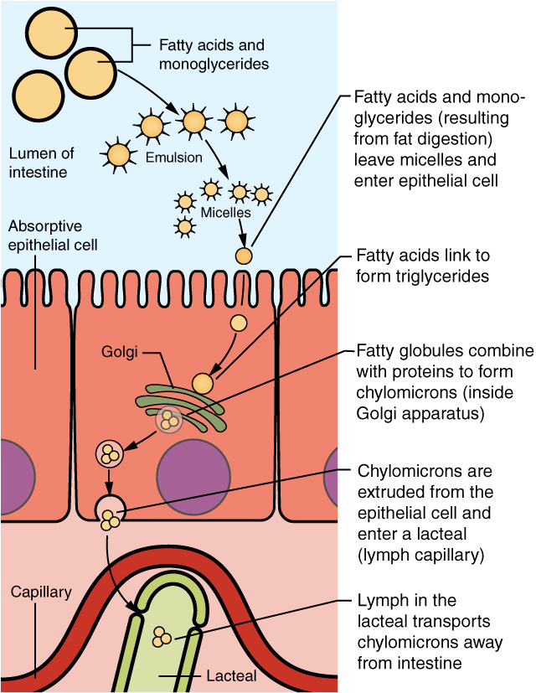

Absorption in the Alimentary Canal

Food | Breakdown products | Absorption mechanism | Entry to bloodstream | Destination
Carbohydrates | Glucose | Co-transport with sodium ions | Capillary blood in villi | Liver via hepatic portal vein
Carbohydrates | Galactose | Co-transport with sodium ions | Capillary blood in villi | Liver via hepatic portal vein
Carbohydrates | Fructose | Facilitated diffusion | Capillary blood in villi | Liver via hepatic portal vein
Protein | Amino acids | Co-transport with sodium ions | Capillary blood in villi | Liver via hepatic portal vein
Lipids | Long-chain  fatty acids | Diffusion into intestinal cells, where they are combined with proteins to create chylomicrons | Lacteals of villi | Systemic circulation via lymph entering thoracic duct
Lipids | Monoacylglycerides | Diffusion into intestinal cells, where they are combined with proteins to create chylomicrons | Lacteals of villi | Systemic circulation via lymph entering thoracic duct
Lipids | Short-chain fatty acids | Simple diffusion | Capillary blood in villi | Liver via hepatic portal vein
Lipids | Glycerol | Simple diffusion | Capillary blood in villi | Liver via hepatic portal vein
Nucleic Acids | Nucleic acid digestion products | Active transport via membrane carriers | Capillary blood in villi | Liver via hepatic portal vein

A person is said to be overweight if they have a Body Mass Index between 25 and 29 and obese if the body mass index crosses 30. Obesity in the United Kingdom has always been one of the leading preventable diseases. One in every four adults in England is suffering from a mild or severe form of obesity, and a study shows the numbers are increasing. The UK is the leading contributor of the obese population in Europe with an overwhelming contribution of 24.9%. We are here to break down to you the different statistics related to obesity and dealing with it in various aspects such as health care costs, disease, and death, causes and solutions implemented by the government and country.

Overall obesity statistics in the United Kingdom

In England alone apart from the 24.9% of purely obese patients, another large percentage number of 61.7% are either obese or overweight. Another recent study says that the current obesity levels that are prevalent today are three times of what was prevalent during the 1980’s. During then a significantly small number of just 6% men and 8% women were reported to be obese. Susan Jebb in her recent study concluded at the University of Oxford that,” overweight kids are most likely to become obese adults.” Another study reveals that obesity is more prevalent among the poor neighbourhoods of London, which is contrary to the common belief. Factors like Income, ethnicity and social deprivation have a significant relation to the number of cases that come up every year related to obesity.
Statistics among men
Obesity is quite prevalent among British men with a significant number, 22.1%, being obese which the second highest n the world is after Malta. What is surprising is that the figures are far from declining and the statistical institutes have predicted that the number of obese men in the United Kingdom will go up to 36% of people by 2030.
Statistics among women
The statistics among women are not pleasant as well, with one out of twelve British women are termed as Clinically Obese. The number of overweight or obese has become an alarming 59%. If this trend continues, as more and more women are falling under the category of obese and overweight the numbers will reach up to 64% by the year 2030.
Healthcare costs related to obesity
According to a study, the United Kingdom spends about 48 billion pounds a year dealing with health care and social causes related to obesity. It is a billion more than what is spent on armed violence and war funds. It has been predicted that 44 interventions could lower down the obesity rates by 20% within a span of five to ten years. This would save around 16 billion pounds a year.

Statistics Regarding Diseases and Deaths Related to Obesity

Being overweight or obese increases the occurrence of other diseases such as type 2 diabetes, high blood pressure, heart disease, stroke, and cancer. Some facts related to the conditions occurring along with obesity compared to healthy individuals are:
- Five times more susceptible to have type 2 diabetes
- Three times more prone to develop colon cancer
- Two and a half time more likely to develop high blood pressure which would result in stroke or cancer.
Among other facts that are related to obesity and overweight are that people with BMI of 30-35 have a reduced life expectancy by an average of three years, while BMI over 40 can decrease longevity up to 10 years. Obesity has claims of over 30,000 deaths a year with 9000 of those deaths are recorded by people before their retirement age.
Causes of Obesity
Putting it simply, obesity is caused by eating too much and working too little. It has been claimed that the rise in obesity is not due to the abstinent of willpower but because of major lifestyle related problems such as “obesogenic environment” that encourages people to eat more and unhealthily. The rise in the usage of cars, computers, desk jobs, high-calorie food and marketing techniques that motivate you to buy more are the root causes of obesity.
What is the government doing about it?
For the government, the main task at hand is to tackle and educate more and more of its citizens about the ill effects of being overweight and obese. Governments are encouraging healthier lifestyle with lots of physical activities associated with it. The UK government has tried several times to curb obesity but has failed. So in 2011, it has launched a policy document “Healthy Lives, Healthy People”. It talks about the vision that it has adapted to eradicate obesity by the year 2020. The government has ordered business and private firms to make healthier choices for its clients and customers by its responsibility dual pledges.

Five ways to stay healthy this winter

It may be cold outside, but winter needn't be the unhealthiest time of year for you and your family.
Here are five ways to make sure that, even when your body is telling you to hibernate, you can keep healthy and fit, no matter what the weather's like.
Banish winter tiredness
Many people feel tired and sluggish during winter. This is due to the lack of sunlight, which disrupts our sleep and waking cycles.
Try these tips:
get outdoors in natural daylight as much as possible
get a good night's sleep – go to bed and wake up at the same time every day
destress with exercise or meditation – stress has been shown to make you feel tired
Read more ways to wipe out winter tiredness.
Eat more fruit and veg
When it's cold and dark outside, it can be tempting to fill up on unhealthy comfort food. However, it's important to ensure you still have a healthy diet and include five portions of fruit and veg a day.
If you find yourself craving a sugary treat, try a juicy clementine or satsuma instead.
Winter vegetables such as carrots, parsnips, swede and turnips can be roasted, mashed or made into soup for a comforting winter meal for the whole family. Explore varieties of fruit and veg that you may not normally eat.
Read more about how to get your 5 A Day.
Find recipes for 10 warming hot meals.
Drink more milk
You are more likely to get a cold in winter, so make sure your immune system is in tip-top condition.
Milk and dairy products such as cheese, yoghurt and fromage frais are great sources of:
protein
vitamins A and B12
calcium, which helps keep our bones strong
Choose semi-skimmed, 1% or skimmed milk – rather than full-fat – and low-fat plain yoghurts.
Read more about milk and dairy foods.
Read more about healthy eating.
Try new activities for the whole family
Don't use the cold winter months as an excuse to stay in and lounge around. Instead, get out with the whole family to try out a new activity –maybe ice skating, or taking a bracing winter walk on the beach or through the park.
Regular exercise helps control your weight, boost your immune system, and is a good way to break the tension that can build if the family is constantly cooped up inside the house.
Read more about different types of exercise for you and your family.
Have a hearty breakfast
Winter is the perfect season for porridge. Eating a warm bowlful on a cold morning isn't just a delicious way to start your day, it also helps boost your intake of starchy foods and fibre.
These foods give you energy and help you feel fuller for longer, stopping the temptation to snack mid-morning. Oats also contain lots of vital vitamins and minerals.
Make your porridge with semi-skimmed, 1% or skimmed milk, or water, and don't add sugar or salt. Add a sliced banana, berries or other fruit for extra flavour and to help you hit your 5 A Day target.
Get more ideas for healthy breakfasts.

